Markets

Characteristics of a market economy
- Property rights
- Economic rights
- Sellers and buyers trade based on self interest
- Moral hazard: people are aware of consequences of bad economic decisions
- Limited government role

Market definition
- When buyers and sellers meet voluntarily to exchange goods and services at a given place and time

Types of markets
Product market | Factor market
Goods and services are exchanged | Factors of production are exchanged
Consumers (households) = demand | Consumers (households) = supply
Firms = supply | Firms = demand

Competitive market | Non-competitive market
Large number of buyers | Small number of buyers
Homogenous products | Product differentiation occurs (e.g. hairdresser prices female haircuts cost more than male)
Easy entry into market | Entry into market is restricted
Firms = price takers | Firms = price setters

Factors of production
- Land: all natural resources
- Labour: human input used to create a product (i.e. workers)
- Capital: equipment that is used in the production process
- Enterprise: management/organisation component of companies

Demand

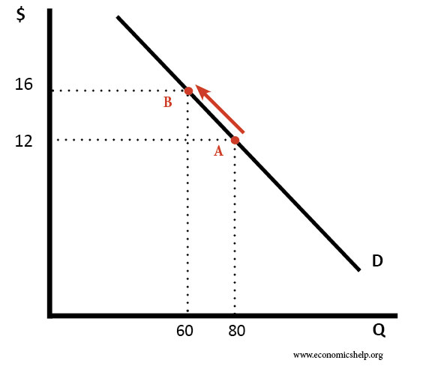
Demand definition
The willingness and ability of consumers to purchase goods and services at a particular time and price

Reasons why demand is a negative slope
- Income effect: less inclined to purchase a good if a product takes up a large percentage of income
- Substitution effect: if price of one good increases, similar goods become more attractive to consumers as they are relatively cheaper
- Law of diminishing utilities: the more one has of a good, the less value they place on it
Figure 1: contraction of demand due to increase in price

Types of demand
- Derived demand: when the demand of a resource depends on the demand of a final good (demand for cotton increases if demand for socks increases)
- Composite demand: when products with multiple uses are demanded (i.e. oil demand related to plastic demand, tyre demand, petrol demand etc.)
- Joint demand: when the demand for a product is dependent on another because they are used together

Law of demand
- As price increases, quantity decreases (inverse relationship)
- Exception to the law of demand:
  - Giffen goods (staple items) – i.e. rice for Chinese
  - Ostentatious goods – i.e. luxury cars
  - Experience goods – i.e. items that have quality associated with price (more expensive TV will be assumed to be better quality
  - Band wagon goods – i.e. if everyone starts selling off shares, other people will

Non-price factors effecting demand
- Population
- Income levels
- Price of substituted and compliments
- Expected future prices
- Taste and preferences – note: for inferior goods, demand decreases if income increases
- Demographic of consumers

Types of changes in demand
- Contraction OR expansion – CAUSED BY CHANGE IN PRICE
  - Movement ALONG the demand curve
  - If price↑, demand ↓ = contraction
  - If price ↓, demand ↑ = expansion
- Increase OR decrease – CAUSED BY CHANGE IN NON-PRICE FACTORS
  - Demand ↑ = shift to the RIGHT
  - Demand ↓ = shift to the LEFT

Supply

Supply definition
The amount of goods and services that producers are willing and able to produce at a particular time and price

Law of supply
As the price of a good or service increases, the quantity of supply increase (as firms seek to maximise their profits)

Non-price factors effecting supply
- Expected future prices
    - If future prices are expected to ↑, supply will ↓ in order to save supply for when profits will be maximised
  - Number of producers in the market
  - Technological advancements
  - Input costs (how much it costs to produce the actual good/service)
  - Government regulations

Types of changes in supply
- Contraction OR expansion – CHANGE IN PRICE
  - Movement ALONG the supply curve
  - If price ↑, supply ↑ = expansion
  - If price ↓, supply ↓= contraction

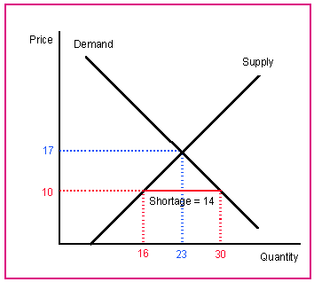
Equilibrium

Equilibrium definition
When the quantity demanded equals quantity supplied at a particular price, meaning the market is cleared

Shortages
- When quantity demanded (Qd) > quantity supplied (Qs) due to price < equilibrium price
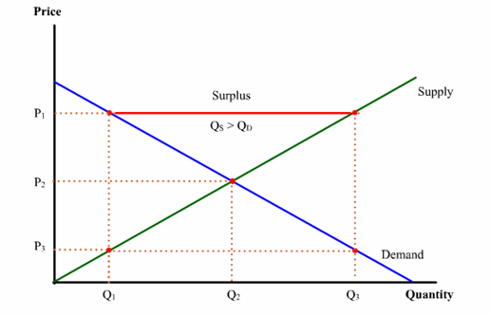
- If Qd > Qs, demand contracts and supply rises until Qd = Qs

Surplus
- When Qs > Qd due to price > equilibrium price
- If Qs > Qd, demand expands and supply contracts until Qs = Qd

Double shifts
- ↑ supply and ↑ demand
- Equilibrium quantity increases
- Equilibrium price unknown
- ↓ supply and ↓ demand
- Equilibrium quantity decreases
- Equilibrium price unknown
- ↓ supply and ↑ demand
- Equilibrium quantity unknown
- Equilibrium price increases
- ↑ supply and ↓ demand
- Equilibrium quantity unknown
- Equilibrium price decreases

Elasticity of demand

Elasticity of demand definition
A measure in responsiveness in quantity demanded to a change in price, shown by the formula $Ed=\frac{∆Q}{AvQ}×\frac{AvP}{∆P}$

Types of elasticity of demand (based on result of formula)
- Perfectly inelastic = 0
  - A change in price will have no effect on demand
- Relatively price inelastic = <1
  - A change in price will result in a less than proportionate change in demand
- Unit elasticity = 1
  - A change in price will result in an equal change in demand
- Relatively price elastic = > 1
  - A change in price will result in a more than proportionate change in demand
- Perfectly elastic = infinity
  - Theoretical – a change in price will result in infinite change in demand

Determinants of price elasticity of demand
- Proportion of income spent: consumers more sensitive to change in price for expensive items
- Availability of substitutes: a lot of substitute goods available means a change in price will cause a smaller effect on demand
- Responding time of consumers: if consumers able to respond quickly to the change in price, the demand becomes inelastic
- Necessity vs luxury good: if someone is addicted to a substance (i.e. meth) this becomes a necessity, and they will continue to purchase it despite large changes in price
- Definition of market: a broader scope of market will be more price inelastic (i.e. clothes will be demanded despite large increases to price, as opposed to silver Seiko watches)

The relationship between elasticity of demand and total revenue
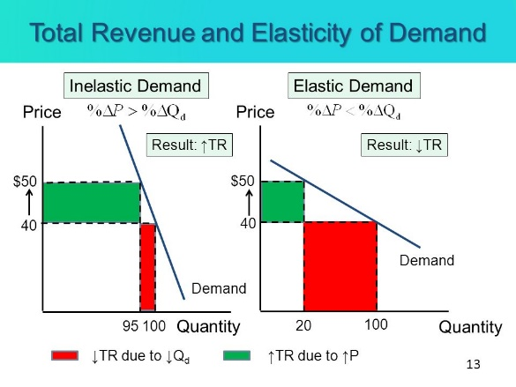
- Total revenue: the total sale of a product at a given quantity and price (where TR = P x Qd)
- Relatively price elastic
  - If demand is relatively price elastic, a decrease in price will result in a greater than proportional increase in quantity
  - Thus TR maximised at lower prices FOR ELASTIC
- Relatively price inelastic
  - If demand is relatively price inelastic, an increase in price will result in a less than proportionate increase in quantity demanded
  - Thus TR maximised at lower prices FOR INELASTIC
- Unitary price elastic
  - No change to TR

Income elasticity of demand

Income elasticity of demand
A measure of responsiveness to a change of quantity demanded to a change in consumer income, shown by $YEd=\frac{∆Qd}{AvQd}×\frac{AvY}{∆Y}$ (given with a + or -)

Types of income elastic on demand
- Inelastic = necessity
- Occurs when 1 < YED < 0
- Negative income elasticity = inferior good
  - Where an increase in level of oncome causes a decrease in quantity demanded
- Positive income elasticity = normal good
  - Where an increase in the level of income causes an increase in the quantity demanded

Cross elasticity of demand

Cross elasticity of demand definition
A measure of responsiveness of a quantity demanded to a change in price of good X to good Y, shown by $XEd=\frac{∆QdA}{{QdA}_{Avg}}×\frac{{PB}_{Avg}}{∆PB}$ (given with a + or -)

Types of cross elasticity of demand
- Positive XED = substitute good
  - Where an increase in the price of good X causes a decrease in the quantity demanded of good Y
- Negative XED = compliment good
  - Where an increase in the price of good X causes an increase in the quantity demanded of good Y
- XED is zero = unrelated goods

Price elasticity of supply

Definition of price elasticity of supply
A measure of the responsiveness to a change in price in quantity supplied, shown by $XEd=\frac{∆QdA}{{QdA}_{Avg}}×\frac{{PB}_{Avg}}{∆PB}$

Types of price elasticity of supply
- Perfectly inelastic = 0
  - Change in price causes no change in quantity supplied
  - Occurs for goods with limited supply ( i.e. Mona Lisa)
- Relatively price inelastic = 0 < Es < 1
  - A change in price causes a less than proportionate effect on quantity supplied
- Unitary price elastic = 1
- Relatively price elastic
  - A change in price causes a more than proportionate change on quantity supplied
- Perfectly price elastic
  - A change in price causes an infinite amount of change in quantity supplied (theoretical)

Determinants of price elasticity of supply
- Production time: longer production time means there is a slower reaction to changes in price, thus making the product price elastic
- Excess capacity: if a firm has excess capacity, it can easily change in reaction to changes in price thus making the product price elastic
- Nature of industry
- Mobility of resources: refers to how easy it is to relocate resources if resources are mobile, the product is price inelastic
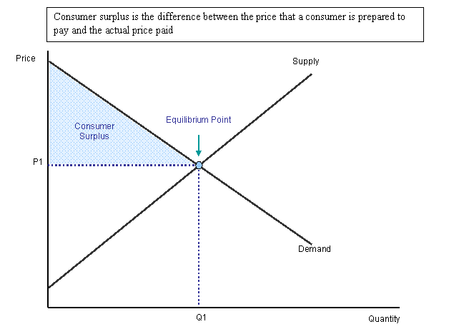
- Complexity of production process: complex production process means it takes longer to adjust to price changes and thus is price inelastic

Efficiency

Efficiency definition
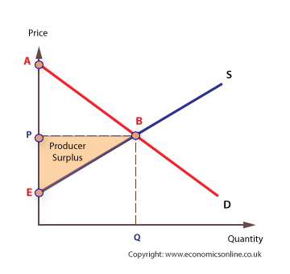
The way in which limited resources are allocated in order to maximise total surplus and thus economic welfare of individuals within the economy

Terms
- Consumer surplus: the difference between price paid and price consumer prepared to pay
- Producer surplus: difference between what producer was willing to receive and what they actually received
- Total surplus: measure of net benefits received from the production and consumption of a good or service, shown by TS = PS + CS
- Dead weight loss: a decrease in total surplus, occurring when a market operates inefficiently
  - Reasons for DWL: tax, subsidy, price ceiling and price floor

Price ceiling
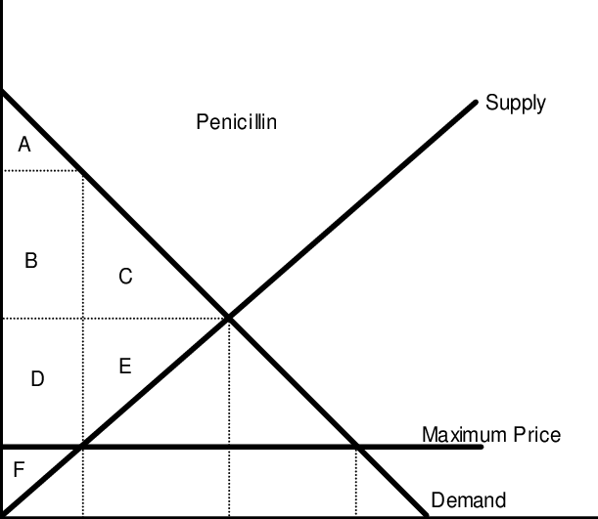
- Definition: a legislated maximum price to be charged of a good or service which is set bellow equilibrium price, resulting in a shortage
- Explanation example:
  - Consumer surplus increases from ABC to ABD
  - Producer surplus decreases from DEF to F
  - Shortage is created because Qd>Qs, as per the law of demand
  - Deadweight loss is created at CE
  - Price ceiling results in a shift from QE to QD at PC, and a shift from QE to QS at PC
  - A black market price is created at PBM (above PE)
- Price ceilings are justified on the grounds of equity as they allow low income earners to afford a good
- However, as the shortage is created, the market cannot guarantee that only low income earners are benefiting from the price ceiling

Price floor
- A legislated minimum price that can be charged for a good or service which is above the equilibrium price, resulting in a surplus
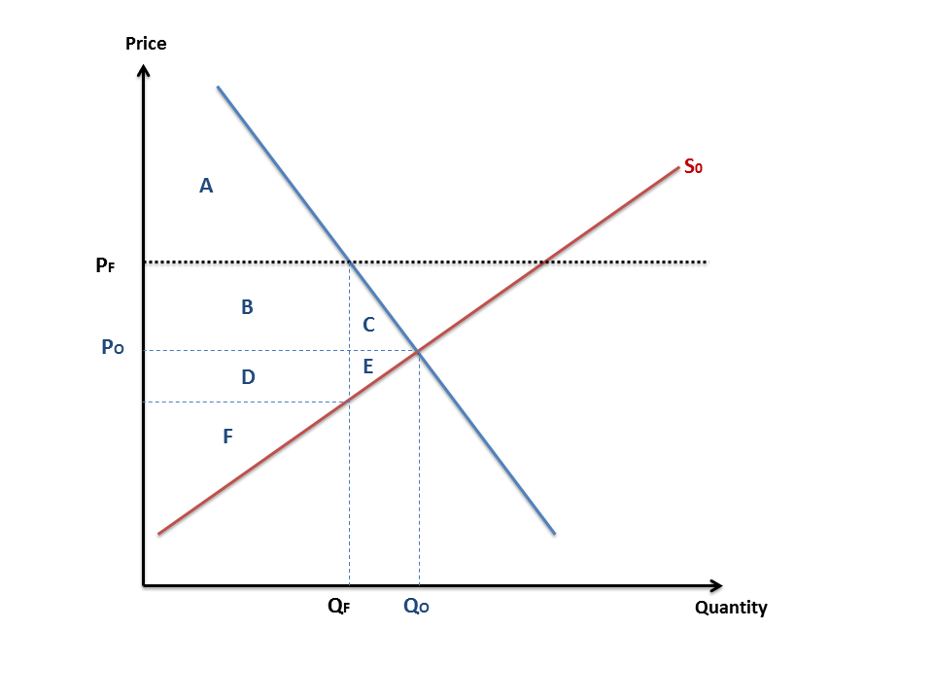
- Explanation example:
  - Consumer surplus is decreased from ABC to A
  - Producer surplus is increased from DEF to BDF
  - Deadweight loss is created at CE
  - Price floor results in QS>QD, surplus created as per the law of supply
  - PF intersecting at D and intersecting at S shows the value of surplus
- Price floors justified on the grounds that it helps low income producers earn higher profits and compete with higher income producers
- However, surplus is created does not necessarily mean more profit is being made

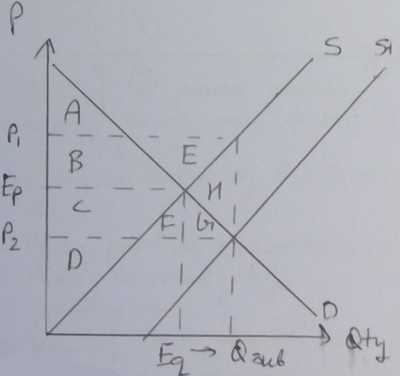
Subsidy
- A grant paid to producers to increase the level of output produced
- Note: only market failure graph with a deadweight loss on the right hand side
- Explanation example:
  - A subsidy causes the supply to shift right from S to S1
  - The Quantity Demanded and Quantity Supplied expands from Equilibrium quantity to Qsub
  - The price paid to producers = P1
  - The price paid by consumers = P2
  - Subsidy Paid = (P1-P2) $×$ Qsub = B+C+E+F+G+H
  - Consumer Surplus = A+B+C+F+G
  - Producer Surplus = D+G+B+E
  - Total Surplus = A+B+C+D-H
  - A Dead Weight Loss of H occurs
- Subsidies increase equity for consumers as more people can access cheaper goods
- However subsidies decrease equity for high income earners as the subsidy comes from their taxpaid money

Taxation
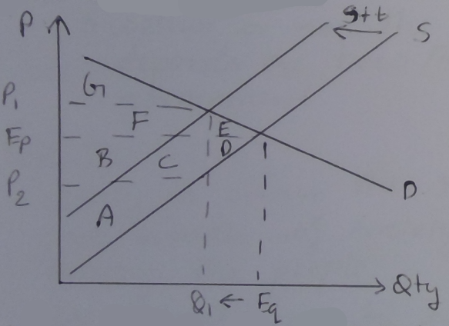
- an involuntary fee places on an individual or group in order to finance government expenditure
- Example explanation:
  - Tax of ‘T’ is placed causing supply to decrease from S to S+T
  - Net contraction of Demand and Supply to Q1
  - Price charged to consumers = P1
  - Price received by producers = P2
  - Tax of F+B+C is placed
  - Burden on consumers = F
  - Burden on producers = B+C
  - A Dead Weight Loss of E+D
  - Producer Surplus = A
  - Consumer Surplus = G
  - Total Surplus = A+B+C+F+G
- Taxation used to increase equity through direct and indirect payments of the government
- Taxes on income increase vertical equity (as rich are taxed more)

Equity
- Definition: when resources, opportunities and wealth in society is equally divided among the people
- Vertical equity: when rich pay more because they can pay more
- Horizontal equity: everyone paying the same if they earn the same in tax

Market power

Market power definition
The ability of a firm to influence the price and quantity of output in a market. Large market power requires a large share of the market, high prices due to being able to set high prices, and protection of their firm/industry.

Barriers to entry
- Patents
- Brand loyalty
- Exclusive dealing
- Anti-competitive behaviour: mergers, predatory pricing, misusing power in an illegal way

Externalities
- Merit goods: goods that are under consumed in the eyes of society and have a positive externality attached. E.g. health care, education, libraries
- Demerit goods: goods that are overconsumed in the eyes of society and have negative externalities associated with them
- Externalities: exist when economic decisions create external costs for the individual or bystander
- Negative externality: when economic actions via production of consumption create external cots for a third party
- Positive externality: when economic actions create a benefit to third parties via external costs

Negative production externality (only need to know negative production, NOT consumption)
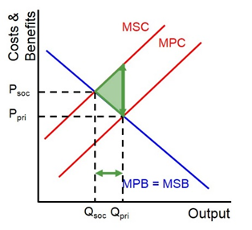
- e.g. production of pollution via fossil fuel combustion
- Example explanation:
  - Social cost > private cost
  - Private quantity > social quantity hence overproduction
  - Note that the market functions efficiently at PsocQsoc (where the DWL points)
  - Value of external cost = distance between MSC and MPC
  - To internalise the externality, MPC must be shifted up through taxation
  - Additionally, education may be used – this causes MPB to shift to the left

Positive consumption externality (only need to know this NOT positive production)
- E.g. flue vaccination
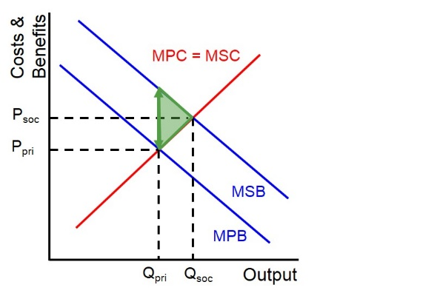
- example explanation:
  - MSB > MPB, therefore underconsumption
  - Market functions efficiently at PsocQsoc (where the DWL points)
  - External cost value = distance between MSB and MPB
  - DWL is created
  - To internalise the externality, shift MPB right to through education
  - Shift MPC down through subsidies

Types of goods
 | Rival | Non-Rival
Excludable | Private Goods (Clothes, Food) | Club (Cable TV, Cinemas)
Non-Excludable | Common (Fisheries, Forests) | Public (Air, Sunshine)

Free rider effect
Public goods suffer the free rider effect as they are non-excludable and non-rival, meaning individuals are able to exploit the good

Tragedy of the commons
Occurs when non-sustainable use of common goods leads to an exploitation of said good. Government may regulate the use of fishing in order to maintain the resource, or may educate people in order to limit the amount of exploitation

Circular flow of income

Macroeconomics versus microeconomics
Macro | Micro
Aggregate behaviour of the economy | An individual’s economic behaviour
Whether resources are fully utilised | Market failure and the governments role in correcting it
A country’s ability to satisfy wants | General operation of markets

CFY model (income = Y)
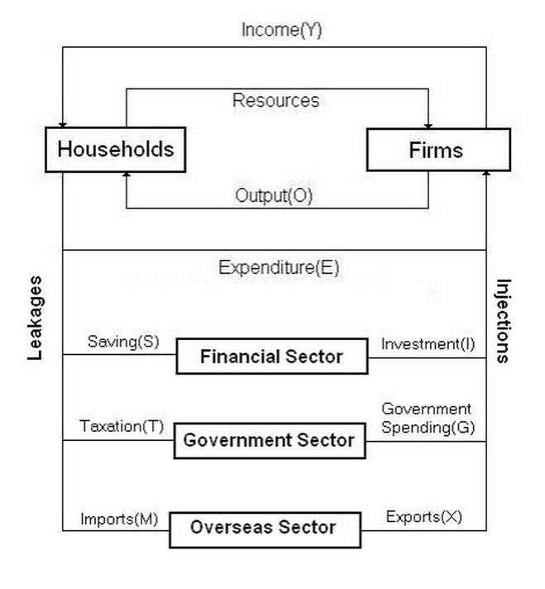
- Households: all individuals in an economy who earn an income
- Firms: private businesses who produce and distribute goods and services to consumers
- Equilibrium: when leakages = injections (savings + tax + imports = investment + expenditure + exports OR S+T+M=I+G+X)

Aggregate expenditure
- Definition: the total sum of consumption from each income level and sector in the circular flow of income, which equals consumption/expenditure + investment + government spending + exports – imports
- Components of aggregate expenditure:
  - Aggregate consumption
    - Durable goods (over 3 year life)
    - Non-durable goods (under 3 year life)
    - Services
    - NOTE normally takes up 50% of GDP
  - Private investment
    - Most volatile component of AE as has most amount of risk associated
    - Expenditure on capital goods used to make final goods
  - Government spending
    - Current expenditure – day to day spending
    - Capital expenditure – future needs
  - Exports-imports (net exports)
    - Volatile!
- Factors effecting aggregate expenditure:
  - AC
    - Disposable income
    - Cost and availability of credit – interest rate
    - Future expectations of consumers
    - Government policy
  - Private investment
    - Interest rate
    - Cost of repayments
    - Opportunity cost – the next best alternative forgone
    - Business expectations
    - Profitability
    - Government policy
  - Government expenditure
    - Government economic objectives
    - Government climate conditions
  - Net exports
    - International economic condition
    - Actual climate conditions
    - Exchange rate
    - Quotas/tariffs

Business trade cycle
Phases of cycle | Result
Peak | - economy reaching full employment  - high inflation  - low unemployment  - high consumer and business confidence
Downswing | - slow economic growth (may become negative), MEASURED BY GDP  - increasing unemployment  - decreasing business and consumer confidence  - decreasing interest rates
Trough | - economy slumping  - low business and consumer confidence  - low inflation rate  - high unemployment
Upswing | -increasing economic growth  -Falling unemployment rate  -Increasing interest rates  -Increasing inflation

Types of indicator | Examples
Leading indicator | - Share prices  - Building loan approvals  - Employment vacancies  - Business and consumer confidence  - Stock/inventory levels
Coincident indicator | - Retail sales  - Car registrations  - GDP
Lagging indicators | - Unemployment rate  - Inflation rate

Economic growth

Economic growth definition
The increase in capacity of an economy to produce goods and services overtime, measured by GDP, to satisfy the wants of the economy

Gross domestic product
- Definition: the total market value of all final goods and services produced in a country during a certain period of time (usually 1 year), shown by $GDP\%∆=\frac{GDP(year2) }{GDP(year1)}-1 ×100$
- Types of GDP:
  - Nominal: the value of output expressed in the prices of the day
  - Real: value of GDP taking into account inflation
  - Real per capita: taking into account inflation per person in the economy
- Limitations of GDP:
  - Measures value of output, not ability of output to satisfy wants
  - Does not account for goods without monetary value (i.e. volunteer work)
  - Does not take into account international price differences
  - Does not account for income distribution
  - Does not account for working standards
  - Does not account for environmental degradation
- Supply and economic growth:
  - Increasing efficiency in economic growth via factors of production:
    - Land – increase amount of natural resources available
    - Labour – increase skills of labour, increased population growth or increased migration
    - Capital – increase productivity through better technology
      - Capital widening: capital stocks increasing at the same time as the labour force
      - Capital deepening: increase output via better technology
    - Enterprise – increase willingness to trade
- Demand and economic growth:
  - Factors that effect spending in the economy:
    - Aggregate expenditure (consumption, investment, government expenditure, net exports)
Benefits of economic growth | Costs of economic growth
Increase material standards of living – satisfy more wants and needs | Structural unemployment
Increased quality of goods and services | Environmental degradation – pollution, decrease in biodiversity, climate change, decreased natural resources
Increased levels of real income | Social dislocation – workers moving for work etc.
Reduced unemployment
Government can run budget surplus – pay back government debt
Increased business investment

Inflation

Inflation definition
The persistent and appreciable rise in the general level of prices, measured through CPI

Consumer price index
- CPI based on a basket of goods and services
- Goods have assigned different weightings – housing roughly 22%, communication roughly 3%
- Rate of inflation = rate of change in price index from one period to another
- Drawbacks of CPI:
    - Does not reflect changes in consumer preferences
    - Does not reflect substitution of goods
    - Cannot account for changes in quality

Demand pull inflation
- Definition: high levels of inflation caused by high levels of aggregate expenditure
- High levels of AE caused by:
    - Excess monetary supply
    - Household energy price rises, leading to wage rise
    - Excess demand for labour, leading to increased wages and thus increased prices

Cost push inflation
- Definition: rising production costs are passed onto consumers, therefore causing higher prices for goods and services
- Caused by:
    - Increased oil prices
    - Wage rises: growth in wages due to increase in productivity growth
    - Government policy: increases in taxes
Benefits of low inflation | Costs of high inflation
low inflation encourages investment | Decreases living standards for low income earners
Creates stability in that firms can predict future costs and prices | Bracket creeping of taxation due to increased incomes
Low inflation increases competitiveness by making export prices lower | Reduction of purchasing power due to decreasing of real income
Prevents boom phases (unsustainable economic growth) in the business trend cycle | Decrease in consumer and business confidence

Unemployment

Definitions
- Unemployment: the proportion of the labour force who are willing and able to work but have not been employed with at least 1 hour of work in the week that they were surveyed
- Frictional unemployment: unemployment that occurs when a worker leaves one job in search for another
    - Short term
    - May benefit the economy in that productivity increases due to finding more satisfying positions
- Cyclical unemployment: unemployment that occurs due to changes in the business trade cycle
- Structural unemployment: unemployment that occurs when there is a mismatch of available and required skills in a geographical/occupational sector of the economy
    - Causes:
      - Changes in technology
      - Business closure and restructuring
    - Usually leads to long term unemployment
- Underemployment: workers who are seeking fulltime work but are only employed with part time work
- Participation rate: refers to individuals who are employed and who are unemployed
- Underutilisation rate: sum total of those employed and underemployed

Natural rate of unemployment
- Definition: the minimum level of unemployment which can be achieved given the current characteristics of the labour market
- Natural rate of unemployment cannot = zero because:
    - Of structural employment
    - Of minimum wages preventing labour marker operating at maximum efficiency
    - Of regulations impacting demand and supply

Full employment
- Economy functions near full capacity
- Creates bottlenecks in the labour force
- Causes inflationary pressure

Negative effects of unemployment
- Decrease in aggregate consumption, investment and business confidence
- Results in welfare payments from the government – decreased gov. revenue
- Loss of output
- Loss of income
- Social costs -i.e. depression

Relationship between inflation and unemployment
An inverse relationship occurs, as unemployment moves counter to the business trade cycle (is a lagging indicator), and inflation moves with the business trade cycle (is a coincident indicator)

Balance of payments

Australian trade
Imports |  |  | Exports
Partners | Specific products | General products | Partners | Specific products | General products
CHINA | Personal travel | Intermediate goods | CHINA | Iron ore | Minerals and fuels
USA | Passenger motor vehicles | Consumption goods | JAPAN | coal | Services
JAPAN | Refined petroleum | Capital goods | USA | education | Manufactures

Structure of balance of payments
- Balance of payments: record of payments between Australia and other economies
    - Debit: payments and financial outflows
    - Credit: receipt and financial inflow
- Current account (usually in deficit)
    - Includes all money flows in and out of a country and exports and imports of goods and services, plus income flows and net transfers
    - Subsections of current account:
      - Goods: primary/non-manufactured products
      - Services:
      - Primary incomes: profits, interests and dividends
      - Secondary incomes: one way transfers i.e. foreign aid
- Capital and financial account (usually in surplus)
    - Shows the net change in foreign assets of a country due to foreign investment and borrowing
    - Subsections include:
      - Capital account: capital associated with foreign aid (money brought to Australia via migrants)
      - Financial account: all foreign borrowing and international sales
        - Direct: investor has >10% ownership
        - Portfolio: investor has <10% ownership
      - Net errors and omissions: data that has been left out or recorded incorrectly
- Why does the balance of payments account always = zero?
    - If one account in surplus, the other account in deficit of the SAME VALUE
    - This is due to the floating exchange rate: the exchange rate will move from one equilibrium position to another meaning demand (caused by inflows) = supply of currency (caused by outflows)

Income distribution

Types of income
- Private income: income from employment, interest, rent, dividends and profits
- Gross income: private income + pensions
- Disposable income: gross income – taxation
- Final income: disposable income + indirect benefits

Measurement of inequality
- Lorenz curve: diagram showing the % of income received by different section of the population
  - Note that if income distribution was completely efficient, the line would be directly proportional
  - The more the curve dips away from the line of equality the more uneven the distribution of income
- Gini coefficient: a measure that indicates the degree of concavity of the line on the Lorenz curve
  - Measured based on the area of the curve divided by the combined area of curves on the graph (if multiple lines shown)

How income is redistributed
- Transfers from government: I.e. pensions, unemployment benefits and childcare rebates
- Social wages: benefits from government that are free such as Medicare, as this increases low income earners purchasing power
- Direct taxation: taxation on income flows, i.e. personal income tax funds levied form government revenue which assists other forms of redistribution (includes horizontal and vertical equity!)

The public sector

Role of government
Role type | Outline
The provision of goods and services | Allocate resources to the goods and services under-provided by the private sector, including:  - Public goods  - Merit goods  - Prevent tragedy of the commons occurring
Redistribution of income | Use tax and transfer systems to achieve equity in income distribution in order to maintain minimum standard of living  - Direct taxation  - Welfare payments  - Indirect government payments  - NOTE: mention horizontal and vertical equity!
Regulation of business enterprises | Fix or prevent market failure, including:  - Negative externalities  - Monopoly power  - Common property resources  - Information gaps
Stabilising the business trade cycle | Use of fiscal policy and supply-side measures to control the business cycle and achieve macroeconomic objectives i.e.:  - Economic growth  - Price stability  - Full employment  - E.g. decrease interest rates to stimulate expenditure in trough

Size of the public sector
- Australian public sector grew at fast rate during Whitlam gov. (1972-1975) due to introduction of Medicare and free Uni
- Australian public sector at 25% of GDP is:
  - Small by international standards
  - Has grown long term, but is relatively stable
  - Measured by looking at what is achieved as opposed to the cost of inputs, and measuring productivity is difficult

Government spending
Area | Examples | Percentage
Social security and welfare | Aged pensions, veterans assistance, unemployment support | 34%
Payments to state, territory and local government | GST transfer | 19%
Health | Medicare benefits | 16%
Education |  | 7%
- government tiers:
  - national: 90% of income comes from taxation
  - state/territory: funding from commonwealth transfers and state taxation
  - local: funding from rates, supplemented by higher government grants

Taxation

Types of taxation
- Direct: taxes on income, profit and increases in wealth
  - Impact (where levied) and incidence (who pays) always falls on the same person
- Indirect: taxes based on things such as consumption or undertaking a transaction
  - Impact and incidence fall on different people
Direct tax |  | Indirect tax
Name | Description | Name | Description
Personal Income Tax | Progressive tax, levies on all wages and salary income | Goods and Services Tax | Impact on seller, incidence on consumer
Fringe benefits Tax | Levied on the value of non-cash benefits given to employees | Excise | proportional
Carbon tax | Proportional tax, impact on producer, incidence on consumer of energy | Customs Duty | indirect tax
Company and Resource Rent Tax | Proportional tax, incidence on consumers, impact on company
Capital gains tax | Progressive, levied on the profits from a sale of assets held for a period >12 months

What make a good tax
- Horizontal equity: tax payers who earn the same pay the same
- Vertical equity: tax payers who are able to pay more do pay more
- Simplicity
- Efficiency: cost of collecting tax = benefit of collecting tax

Macroeconomic performance
Objective | Definition | Key indicator | Notes
Economic growth | An increase in the capacity of the economy to satisfy wants of members of the economy at a sustainable rate | Rate of change in GDP | Target rate between 3-4%
Price stability | Little or no sustained appreciation in levels of price | Rate of change in CPI | Target rate of 2-3%
Full employment | Availability of work for those who are willing and capable members of the work force | Unemployment rate | Natural rate of unemployment roughly 5% allowing for cyclical unemployment
Equitable income distribution | Improving fairness in the community by spreading communal income over different socio-economic groups | No indicator, but a Gini coefficient may be used to show income distribution | No target for Gini coefficient – a coefficient is something to aim towards but cannot be 0 as this decreased competition in economy
Efficient distribution of resources | Government aims to improve distribution of resources by stimulating competitiveness and reducing market monopolies | No indicator | Government implements organisations such as ACCC and PC to increase competition and thus increase efficient distribution of resources

